KUTC JOINT PROJECT INTERIM ASSESSMENT REPORT
Assessment Period 17/08/2021– 30/11/2022
Combined Report (KU + External Research Partners)

Project Details
Budget Code: | 8474000259
KUTC Reference | KUTC01
Full Project Title: | Development of solid electrolytes for harsh environment batteries
Principal Investigator: | Daniel Choi
Co-Investigators:
Research Staff: | Prerna Chaturvedi
PhD Student(s):
MSc Student(s):
Project Start Date: | 26/11/2019 | Project End Date: | 25/11/2022
External Collaborator | Hae Jin Kim (KBSI in South Korea)
KU Budget Allocation | (AED) 1,101,750 for 3 years
Partner Budget Allocation | (AED) 1,102,000 for 3 years
Total Project Budget | (AED) 2,203,750 for 3 years

Total Project Budget per Fiscal Year (AED)
2019 | 2020 | 2021 | 2022
31,750 | 367,250 | 367,250 | 335,500

Actual Expenditure to Date (AED)
2019 | 2020 | 2021 | 2022
4,520 | 35,000

Summary of Project & Deliverables to date (min. 2 / max. 3 pages) + Gantt Chart (Plan vs Progress)

In this time period, we have demonstrated integration of three components (cathode, anode and solid electrolytes) into full-cell flexible LIB batteries:
Once free-standing and flexible all the major battery components (cathode nanocomposites, anode nanocomposites and solid electrolyte films) are ready, those are integrated to build full-cell batteries. Figure 5 shows a schematic diagram showing a few steps towards integration of three components to build a full-cell battery.

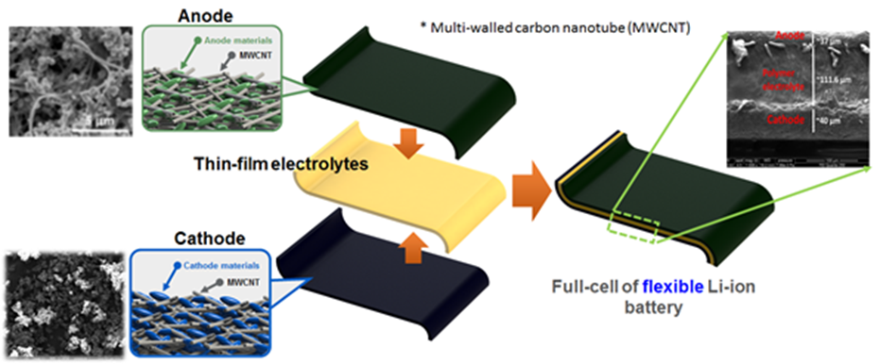

Figure 1: A schematic diagram describing ‘Integration process’ for fabrication of full-cell LIB with SEM images of CNT-based nanocomposites of cathodes, anodes and cross-sectional view of SEM image of the integrated full-cell LIB.

In addition, we have developed the process for fabrication of ultra-thin hybrid solid electrolyte membrane (HSEM)
- Flexible, light-weight, PVDF-HFP Ta-doped LLZO based HSEM with a simple ‘drop casting process’ which is a low cost and mass producible (compatible to “Roll-to-Roll” process) process
- The ionic conductivity of the HSEM membrane is ~10-3 S/Cm at room temperature

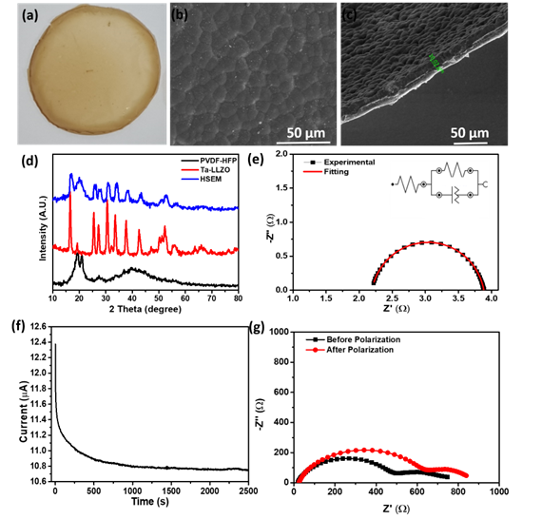

Figure 2: (a) Photograph of HSEM, (b) FESEM showing top view of HSEM, (c) FESEM showing side view of HSEM, (d) XRD patterns of PVDF-HFP, Ta-doped LLZO and HSEM, (e) Nyquist plot of HSEM and its equivalent circuit (in inset), (f) polarization current versus time for HSEM and (g) Nyquist plots before and after polarization.

Tasks/Milestones | Year 1 |  |  |  | Year 2 |  |  |  | Year 3
Task 1: Development of LITFSI in PYR14TFSI ionic liquid based gel polymer electrolyte (KU)
Progress
Task 2: Development of Li superionic conductor solid electrolytes (KBSI/ YHK, JGK, MYS)
Progress
Task 3: Development of porous CNT nanocomposite by freeze casting method (KU)
Progress
Task 4: Testing half-cells (KBSI/WGH,JGK)
Task 5: Modelling and simulation of the solid electrolytes - SEI formation (KBSI/HJK)
Progress
Task 6: Thermal analysis of solid electrolytes (KU)
Progress
Task 7: Fabrication of full-cell batteries (pouch cell) – single cell (KU/KBSI/WGH,YHK)
Progress
Task 8: Fabrication of full-cell batteries (pouch cell) – multiple cells, stacked batteries (KU/KBSI/WGH)
Progress
Task 9: Testing/demonstration of full-cell batteries (pouch cell) as a prototype for EV battery (KU/KBSI/WGH)
Progress
Task 10: Harsh environmental tests of prototype full cell batteries (KBSI/WGH, JGK)
Progress

Challenges Faced & Mitigation Plan (min. 1 page)

In this time period, we have worked on development of thin and high ionic conductivity solid state membrane. The materials is not stable under humid environment. In order to improve reliability of the solid state membrane, we will try to add fillers and additives.

For Garnet based nanocomposite electrolytes, we incorporated those material in freeze casting to fabricate porous structure. The process was successfully developed.

.

Summary of External Research Partner Contributions to Date (min. 500 words per Partner)

KBSI have developed ‘Super-ion based solid electrolytes’ with high ionic conductivity of 10⁻³ S/cm at room temperature. Their electrochemical performance shows over 90% capacity retention during 100 cycles of charge and discharge, and about 75% capacity retention even after 1500 bending tests. In addition, the stacking technique was applied to internal composite electrodes for improving the energy density of all-solid-state batteries. Dr. Kim’s group is also continuously developing novel solid electrolyte and next-generation all-solid-state batteries which are closely related to this project.

** Only outputs specifically referencing this KUTC award by way of acknowledgment of funding will be considered an award output **
Project Output Data – Specific to this Project during the report period
Journal Publications (Include full reference details including DOI)
KU Sole Authors | - A. Lokhande, D. Choi, “High performance Li-ion capacitor based on novel carbon-coated chalcogenide anode”, Journal of Energy Storage, 50, 104251, 2022.  - A. Lokhande, A. Shran, S. Nair, A. R. Shelke, V. C. Karade, J. H. Kim, N. Singh, D. Choi, “Self-supported graphene oxide encapsulated chalcopyrite electrode for high-performance Li-ion capacitor”, Journal of Energy Storage, 2022 (Accepted for publication).
KU + Project Partners (Joint) Authors
Project Partners Sole Authors

Conference & Workshop Presentations (Include presentation title, event name, month/year)
KU Sole Presenter
KU + Project Partners (Joint) Presenters
Project Partners Sole Presenter

Invention Disclosures – Files/Granted Patents (filing reference / patent number)
KU Sole Inventor | P. Chaturvedi, D. Choi “Li-ion battery based on solid electrolyte flexible membrane”. US Provisional Patent  application filed in September 2022, US 63/399,935
KU + Project Partners (Joint) Inventors
Project Partners Sole Inventor
Other Project Outputs (optional)

